**273/1**

**GEOGRAPHY**

**Paper 1**

**2024**

**UCE PREP MOCK EXAMINATION**

**S2 SCORING GUIDE**

**Item 1: Map Skills**

**a) Calculate the distance from home at Doko to school at Poko trading centre**

**3.6km Accept a range of (3.4-3.8km)**

**The amount of money he spends**

**3.6 x 1500 = 5400/=**

**Accept 5,100-5,700/= max score 02**

**b) Area likely to be destroyed**

**area= No. of full sq +No. of half sq**

2

**4+4/2**

**4+2**

**6 grid squares**

**1 grid square =1km²**

**6x1km²**

**6km² max scores 02**

**c) a table classifying features observed around Asukuru**

|  |  |
| --- | --- |
| **Physical features** | **Human features** |
| **Paya Hill** | **Transport routes(roads)** |
| **Papyrus swamp** | **Poko school** |
| **Lake Pine** | **Poko trading centre** |
| **River Tipe** | **Landing site** |
|  | **Borehole** |

**Physical 03**

**Human 03 Max scores 06**

**Sum total 10/10**

**Item 2: Photograph Skills**

1. A learner draws a landscape sketch showing features shown on the photograph.

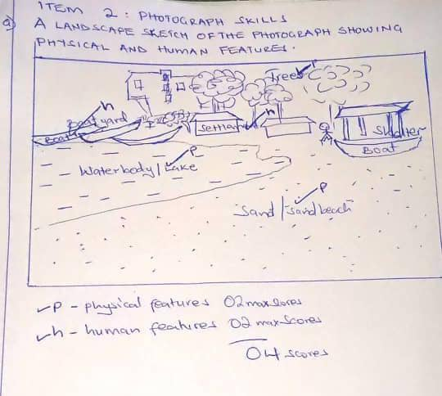

**Scoring:**

Accurately drawn landscape sketch with all features 04

Accurately drawn landscape sketch with most features 03

Accurately drawn landscape sketch with some features 02

Accurately drawn landscape sketch with very few features 01

Wrong or no response 00

**(b) A learner explains the ways through which the fishing communities have misused the fisheries resources giving evidence from the photograph**

* Overfishing: evidenced by dense settlement along the waterbody
* Dumping of wastes from the settlements along the waterbody
* Pollution; through oil spills from engine boats
* Cutting trees to make boats, semi structures for housing evidenced by scattered trees
* Fishing without licenses
* Catching very young fish; this is through use of small size nets.

**Scoring:**

**5** or more ways well explained with evidence from the photograph 04

3-4 ways well explained with evidence from the photograph 03

2 ways well explained with evidence from the photograph 02

1 way well explained with evidence from the photograph 01

Wrong or no response 00

(c) **Measures that the fishermen can put in place to ensure safety of the fisheries resources.**

* Setting and enforcing catch limits to prevent overfishing
* Establishing protected areas where fishing is limited or prohibited to conserve habitats and species.
* Using fishing gears that targets specific species and minimize bycatch
* Regular monitoring of fisheries and enforcing regulations to prevent illegal fishing.
* Establishing closed seasons to protect fish during breeding, spawning or migration.
* Using nets with recommended standard size to protect juvenile fish and allow fish to reproduce.
* Educate the fishing communities about dangers of using poor or illegal methods and tools.
* Sensitize communities about dumping wastes in water bodies.
* Practicing aquaculture to reduce pressure on the waterbody.
* Tree planting through afforestation, reafforestation,

**Scoring:**

5 or more measures well explained 04

* 1. measures well explained 03

2 measures well explained 02

1 measure well explained or merely outlines the measures 01

Wrong or no response 00

**SECTION B**

**Part I**

**Item 3**

1. A sketch map of East Africa showing mountains and the Rift valley

**Scoring:**

Accurate sketch map of EA with the Rift valley and 1 mountain in each country 04

Accurate sketch map of EA with the Rift valley and 1 mountain in two countries 03

Accurate sketch map of EA with the Rift valley and mountains in one country 02

Accurate sketch map of EA with the Rift valley only OR mountains in one country 01

1. **Describing the formation of mountains in East Africa**

The types of mountains found in East Africa are;

**Block mountains eg**

* Pare, Usambara and Uluguru in Tanzania
* Rwenzori at the border of Uganda and DRC
* Danakil Alps of Ethiopia
* Mau ranges and Aberdare ranges in Kenya.

**Volcanic mountains eg**

* Mt Kilimanjaro in Tanzania
* It has three distinct volcanic cones ie Kibo (highest), Mawenzi and Shira (lowest)
* Mt Elgon in Uganda
* Mt Meru
* Mt. Kenya in Kenya

**Formation of Block mtns**

* Block mtns were formed by the process of faulting which was caused by compression forces. The compression forces pushed the earth crust inwards thereby causing the rocks to crack or develop reversed faults. Continuous inward pushing of the blocks of the earth crust, forced the faulted blocks to rise above the surrounding blocks of the country to form block / Horst mountains.

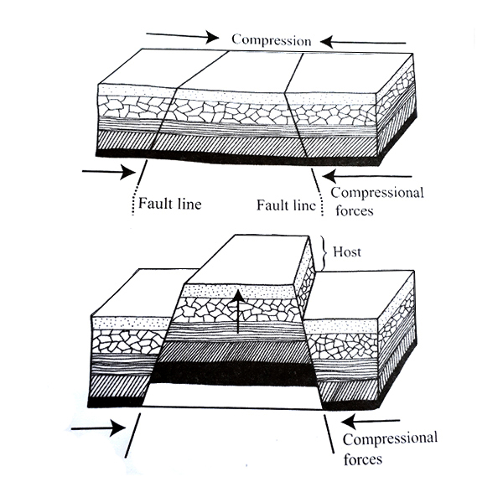

**Formation of volcanic mtns**

* Volcanic mountains are formed by the process of faulting caused by forces within the earth ie tension and compression forces which cause cracks to develop in the crust through which molten rock/ magma passes through. The molten rock/magma is forced out of the earth’s crust by high pressure through the cracks called fissures. When magma reaches the surface of the earth, it forms lava. Lava builds up and solidifies around the vent (zone of weakness) to form a volcanic cone or mountain.

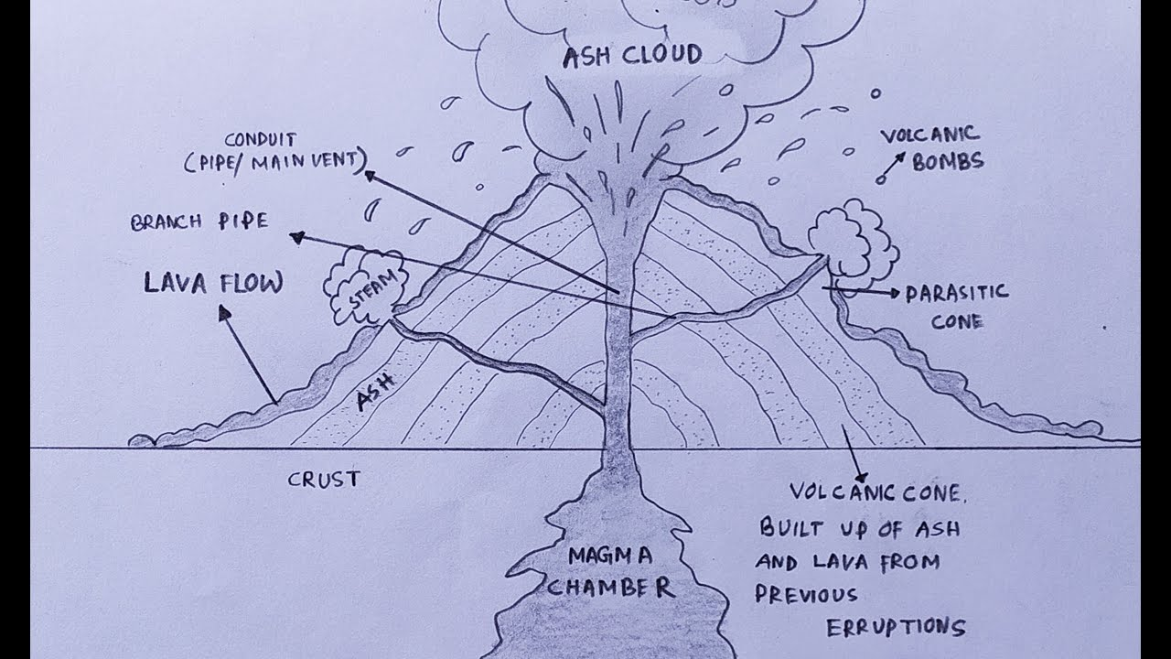

**Scoring:**

1 type of mountain described with processes, examples and illustration 04

1 type of mountain described with processes and illustration, without example 03

1 type of mountain described with processes and examples, without illustration 02

1 type of mountain described without processes, examples and illustration 01

Wrong answer 00

1. **Explain how the people can utilize the physical features to better their well-being**

* Slopes of mtns have fertile soils which can support crop growing
* Rift valley lakes can support fishing
* Mtns have rocks that contain minerals that can support mining/ quarrying
* Slopes of mtns have pastures that can support animal rearing
* Forests on slopes of mtns can support lumbering
* Mtns are sources of rivers which can support generation of HEP

**Scoring:**

5 and more importance well explained 04

3-4 importance well explained 03

2 importance well explained 02

1 importance well explained **OR** merely outlines the importance 01

Wrong answer 00

**Item 4**

1. An essay to explain your findings about why the rift valley region has remained undeveloped.

**Factors limiting development of the rift valley region**

* Earth quakes
* Volcanicity which destroys human life and property
* Steep slopes hinder mechanization of farms hence limiting food production.
* Political instabilities as a result of rebels hiding in the slopes of mountains
* Limited access to credit and financial services eg few banking and financial institutions operating in the region.
* Floods during heavy rains
* Dry conditions on the leeward side of mtns limit agriculture.
* Steep slopes limit transport and communication, electricity access and water supply.
* Soil erosion accelerated by steep slopes eg in Bundibugyo
* Pests and diseases destroy crops leading to food shortage, starvation, malnutrition.
* Frost conditions in the valley destroys crops leading to food scarcity.
* High population density limits land available
* Land fragmentation limits mechanized farming

**Scoring:**

5 or more factors well explained 04

3 to 4 factors well explained 03

2 factors well explained 02

1 factor well explained 01

Wrong or no response 00

1. **Measures that can be put in place to develop the Rift valley region**

* Terracing, contour ploughing to control soil erosion.
* Afforestation, reafforestation, agroforestry programs etc to control soil erosion and floods
* Economic diversification through encouraging mining, manufacturing alongside tourism
* Spraying with pesticides to control pests and diseases
* Land consolidation to encourage mechanization.
* Education and skills development through vocational training, entrepreneurship programs and education infrastructure to enhance human capital.
* Upgrading health facilities, train healthcare workers to address health issues
* Construction of winding roads across slope, improving the roads and bridges to enhance connectivity and access to markets and social services to improve transport.
* Establishing microfinance institutions, credit unions and banking services to increase access to capital.
* Agriculture modernization through promoting irrigation, mechanization

**Scoring:**

5 or more measures well explained 04

3 to 4 measures well explained 03

2 measures well explained 02

1 measure well explained OR merely outlines the measures 01

Wrong or no response 00

**Part II**

**Item 5**

1. **Effects of climate change**

**The effects of climate change can be directly on the people or to the environment as discussed below**

**Effects on the people**

Climate change can lead to heavy rains associated with flooding and destruction of crop gardens and property

Climate change can result into drought which leads to crop failures, extinction of plant species, fish and animals consequently food shortage and famine

Drying up of pastures for livestock due to prolonged drought leading to malnutrition and death of livestock

Leads to shortage of water for domestic use and livestock due to drying up of water sources like rivers, swamps and wells

Heat waves due to increased temperatures leads to death of people, animals and fish in the oceans

Increased levels of ultra-violet radiation in the atmosphere causes human diseases like skin cancer.

**Effects of climate change on the environment**

The increased rainfall as a result of high temperatures causing high rates of evaporation hence causing wet areas to become wetter and dry areas to become drier

It leads to desertification in which desert-like conditions encroach on the formerly productive agricultural land

Global warning due to the greenhouse effects by gases added into the atmosphere and destruction of the ozone layers by CFCs

Reduced water levels in lakes and rivers and climate becomes drier causing less water to infiltrate underground and hence less water to feed the rivers

Extinction of plants and animal species that can not adapt to the higher temperatures

It results into more extreme weather conditions for example storms, drought, heat waves, wild fires and floods

It causes melting of glaciers of the Antarctic and Arctic ice sheets leading to rise in sea levels and submergence of coastal areas causing flooding

It also leads to oceans becoming warmer and marine organisms becoming extinct by damaging the planktons

**Measures to control/mitigate climate change**

Afforestation and reafforestation Agro-forestry to promote rain formation and reduce global warning

Proper vehicle maintenance to reduce on the emission of dangerous gases in the atmosphere

Encouraging the use of environmentally friendly renewable energy like HEP, Wind and Solar and reduce the use of fossil fuels like Coal

Use of energy saving stoves to reduce the rate of deforestation

Use of alternative means of transport like electric trains, cars motor cycles which are environmentally friendly

Sensitization of the local people on the causes, effects and measures of climate change

Treatment and proper disposal of industrial waste materials before disposal in the environment to reduce their effects in the environment.

**Item 6**

1. **Comment on Africa’s ports in handling cargo with evidence from the table**

* The total volume of goods handled by the selected ports in Africa is 7,447,329 million tonnes
* Durban port handles the biggest volume of 2,595,402 million tonnes.
* Mombasa port handles the second largest volume of 1,359,579 million tonnes.
* Tema handles the third largest volume of 1,248,726 million tonnes.
* Walvis port handles the least volume of 154,207 thousand tonnes.

**Scoring:**

4 or more answers with evidence 04

3 answers with evidence 03

2 answers with evidence 02

1 answer with evidence OR merely outlines answers 01

Wrong or no response 00

1. **Measures to improve transport along waterways**

* Construction of embarkments to control flooding of rivers
* Training of vessel crews or personnel on the use of new technologies in water transport
* Upgrade and expand ports, waterways and terminals
* Implement efficient cargo handling practices and technology
* Improving road, railway transport to ease accessibility to ports.
* Install modern navigation aids like GPS and river information systems
* Carrying out research to come up with energy and environmentally friendly water vessels to overcome water pollution by oil spills from vessels.
* Plating trees along river banks to control sediments from degrading the bed of basins and affecting water levels.
* Construction of channels to drain out excess water from the river and allow smooth navigation.
* Constant dredging to control siltation and increase river depth to enable the use of big ships and boats.
* Construction of dams along river channels to control floods so as to ease smooth navigation.

**Scoring:**

5 or more measures well explained 04

3 to 4 measures well explained 03

1 to 2 measures well explained 02

1 measure well explained OR merely outlines measures 01

Wrong or no response 00

**END**